CDKA Series CNC counterblow hammer
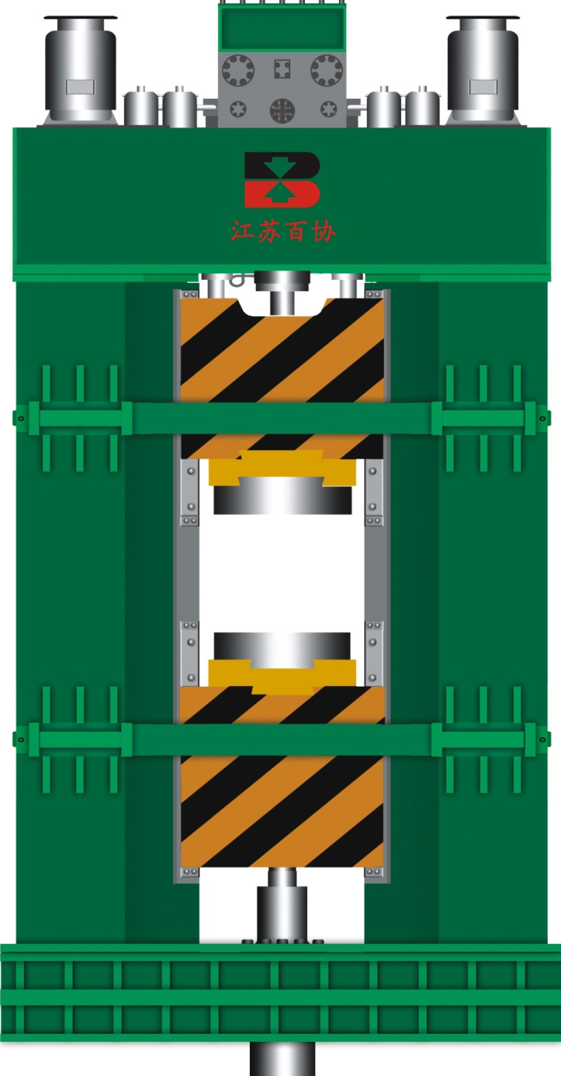

If the large CNC die forging hammer adopts CHK and CDK, it will be difficult to machine and transport due to this relatively heavy framework and need high quality workshop and foundation with high investment cost. So we suggest that you could choose Baixie’s CDKA CNC Counterblow hammer for the large die forging hammer over 125kJ.
Baixie uses the advanced technique of large hammer at home and abroad to design the latest unique CDKA CNC Counterblow hammer on the base of CHK and CDK, which is with hydraulic coupling, fully hydraulic drive, counter blow with different velocities and can realize automation by programmed control.
Baixie’s CNC hydraulic counterblow hammer not only has the simple reliable structure but also has considerate running monitoring systems, fault diagnosis system, energy auto-control system and programmed blow control system. So the CNC hydraulic counterblow hammer has become the advanced precision forging equipment with high adaptability, high effect, energy saving, high precision, high reliability and environmental protection in forging industry.
Structure features:
The weight ratio of the CDKA CNC Hydraulic Counterblow hammers’ upper to the lower tup is 1:1, which are linked by hydraulic linkage, In the drive of hydraulic power the two hammer tups realized relative motion and are guided by framework with same energy, lower hammer tup micro motion and about 6m/s relative velocity
Its framework is assembled by welding steel plate, which won’t support the vertical shock by blow during running. On the top of the framework there is hydraulic power drive system and on the bottom there is elastic damping isolation system. So they will thoroughly avoid the influence of vibration to environment by blow.
CDKA CNC Hydraulic Counterblow Hammers’ hydraulic power drive system adopts the fully hydraulic power drive principle with highly integrated tapered valve control structure to realize high reliable running.
CDKA CNC Hydraulic Counterblow Hammer×s control system realized man-machine conversation, operation status display and common failure display by the touch-screen. It realized the digital control of blow energy and program control of striking.
Performance and feature:
1. High energy-saving
The CDKA hydraulic counterblow hammer is actuated by hydraulic drive system, which makes the energy utilization to 65% and the striking efficiency is up to 95%. However, the traditional hammer has only 2-3% energy utilization and 85% striking frequency. Furthermore, the energy-saving of the CDKA hydraulic counterblow hammer is precisely embodied in controlling of striking energy and it is also a waste of energy of surplus energy.
2 .High accuracy
The CDKA hydraulic counterblow hammer×s precise control of striking energy and the realization of programmed striking can avoid the unstable quality due to operators× different technology level.
3. No vibration
The CDKA hydraulic counterblow hammer×s upper and lower tup strike with equal energy. On the bottom of the frame work there is elastic damping isolation system, which will thoroughly avoid the influence of vibration to environment by blow.
4. Fewer investment
The CDKA CNC hydraulic counterblow hammer not only has a good cost performance ratio but also can economize the base investment and reduce the demand of workshop×s anti-vibration. It is calculated that compared with the same tonnage electro-hydraulic hammer, the cost of the CDKA CNC hydraulic counterblow hammer can be reduced 1/3 only on equipment and foundation. If you put the new workshop into consideration, the reduction can up to 50% due to the reduction ofanti-vibration demand.
5. Lower using cost
The advance of CDKA CNC hydraulic counterblow hammer is not only on high efficiency, energy -saving, high precision, high reliability and environment protecting but also on the good control of striking energy. Giving the forgings enough energy but not more not only can lessen the vibration, reduce the noise, greatly improve the reliability of the equipment but also can extend die’s useful life.

Technical Parameters:
规格  SPEC. | CDKA | 160 | 200 | 250 | 320 | 400
打击能量  Striking energy | kJ | 160 | 200 | 250 | 320 | 400
上锤头质量  Upper ram weight | kg | 18000 | 23000 | 29000 | 35000 | 48000
下锤头质量  Lower ram weight | kg | 20000 | 25000 | 32000 | 39000 | 52000
上锤头打击行程  Upper ram striking stroke | mm | 630 | 700 | 700 | 700 | 700
下锤头打击行程  Lower ram striking stroke | mm | 630 | 700 | 700 | 700 | 700
打击频率  Striking frequency | min-1 | 50 | 50 | 45 | 45 | 40
主电机功率  Motor Power | kW | 220 | 264 | 360 | 440 | 528

